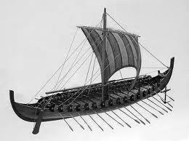
The Odyssey Vocabulary Activity

Step 1: Look up the definitions of these words in the dictionary and then label the diagram of the ship with the terms:

- stern
- rudder
- weigh anchor
- sail
- vessel
- steering oar
- mast
Step 2: Look up the definitions of these words in the dictionary and then paraphrase the definition. For words that have multiple meanings, try to find the definition related to the sea or boats.
- voyage
- embark
- fleet
- navigated
- comrade
- ventured
- peril
- wayfarer
- besieged
- bade (past tense of bid)

